Portland State UniversitY
Dancing Hexapod
ECE478/578 Intelligent Robotics
Rocky Chase, Josh Gerwin, Eddie Strandberg
12/11/2010

Table of Contents
Eddie Strandberg 6
Hardware 6
New electronic hardware 6
Features of the robot 6
Head creation 6
Servo Replacement 7
Wiring Diagram 8
Rocky Chase 9
Movement API 9
Use of Previous Teams Work 9
moveServos 9
doMoveSets 9
setServoPosition 10
setServoSpeed 10
Josh Gerwin 11
Beat Detection 11
Dancing 12
Improvisational Dance 14
Inverting our Assumptions 18
Rocky Chase 19
Future improvements 19
Beat Detection 19
MIDI Control 19
Grammar Decoding Enhancement 19
Integration of Scripted Move Sets 20
Appearance 20
Movement Interpolation and Transforms 20
Appendix 21
Josh Gerwin 21
SOFTWARE SYMBOLS BY FILE (some of them, anyway) 21
Resources by Topic 24

Eddie Strandberg

Hardware

New electronic hardware
The hexapod came with Mini-SSCII servo controllers and a PBasic STAMP microcontroller. We wanted to implement a more complicated algorithm than what the PBasic environment could easily support. In order to do this, we ended up replacing all of the hardware on the bot. It now uses an Arduino Duemilanove and two Pololu servo controllers. The Arduino platform provides a microcontroller for simple interfaces which is programmable in C++. The Pololus are a good step up from the Mini-SSCIIs because you can specify a speed that you want the servos to move at, as well as interface with them through TTL instead of RS232. The Pololus also have a serial out pin which the SSCs do not. This was essential to be able to interface with the Arduino because it uses a RTS CTS type of handshaking to send serial signals.

Features of the robot
The robot will dance to most music. Sometimes it has a hard time finding a beat, especially with music that has a lot of harmonics surrounding the beat. A good way to get it dancing is to lightly tap the microphone with your finger. This will get the beat detection to engage and then it can average out the peaks once it starts dancing. The dancing LED will go solid when it has entered dance mode, and the peak LED will flash when it is detecting a peak in the audio signal. The Arduino can be powered with a 9-volt battery that we have attached to the body of the hexapod. The servos are powered through a 4-6 volt rail that is located on the Pololus. These rails are driven by a Ni-Cad rechargeable battery, the same kind you would find in a hobby shop or remote control car.

Head creation
The head was created from plexi-glass, Styrofoam, and hot glue. We cut the head into a prism like shape to follow the same format as Hexy, the RAS’s Hexapod. A piece of plexi-glass is secured with two screws to the underside of the hexapod’s body. This piece of plexi-glass connects to the wheel of a servo that rotates the head from left to right. Another servo is hot-glued to the body of that servo and is rotated 90 degrees to allow the head to look up and down. We used a piece of Styrofoam cut into a triangle to allow another piece of plexi-glass to connect the second servo wheel to the head. This is because all of the surfaces on the head are at non-parallel angles to the arm connecting it to the servo.

Servo Replacement
When we started working with the hexapod all of the servos seemed to be working fine. After a while of testing and debugging, the servos started to “jitter” into position instead of deliberately going directly to their positions. A lot of strain is put on the motors when a couple of legs are responsible for lifting the weight of the hexapod. This would happen sometimes in dance mode B, which is a more vigorous routine, and the robot would lurch forward. We think that this is the main reason for the jitter. We replaced five servos total.

Wiring Diagram

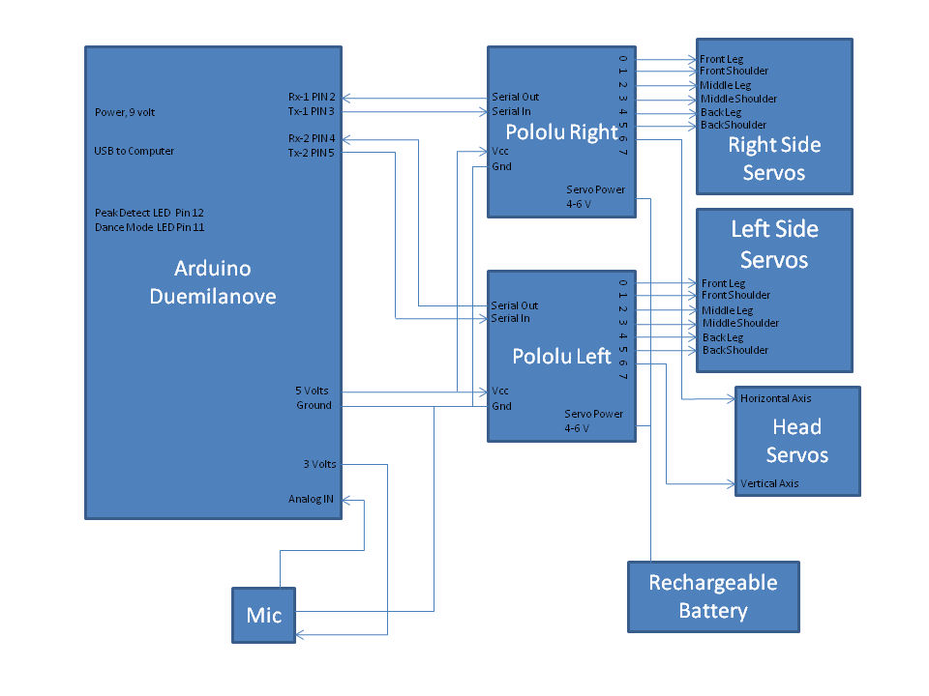

Rocky Chase

Movement API

Use of Previous Teams Work
Two people from the robotics lab, Noah Brummer and Chris Clark, provided us with Arduino code that works with our servo controllers. We used this code as a starting platform to get us started. This provided us with an example of how to communicate with the servo controllers.

moveServos
We created movement API that allows users to have a single interface to work with, that will move all servos to a specified position. The top level interface is the moveServos function that takes a list of servo positions for all of the servos. A servos will not be adjusted if the position sent is the same as the servos’ current position. Also the user can send a special value for the servo position to either make the servo move to a random position or to not adjust the servo. This allows a great amount of flexibility for the way the move sets are arranged.

doMoveSets
This function was originally used to traverse sets of positions before we switched to the improve routine discussed in later section. The user could provide a list of positions sets where each element is a stance (set of positions for each servo). Stepping through each position set on the beat was the original way we made our robot dance.
Although we did not implement it, our original idea was to pass this function a random set of moves and repeat. However, this was quickly switched to the improv routine described in a later section.

setServoPosition
There are is a lower level function that moves a single servo at a time. This function, setServoPosition, is used by moveServos and is also accessible to the user. This function limits the range that is sent to the servo and converts from degrees to a number that is useable by the servo controller. Also this function is aware of which of the two servo controller needs the message. The following is sent to the servo controller by this function:
Start Byte 0x80
Device ID 0x01
Command Number 0x04
Servo Number (one byte representing servo number)
Position Value (one byte representing position value)

setServoSpeed
The function setServoSpeed adjust the speed of a single servo. Similar to setServoPosition it is aware of which of the two servo to send the message to. Currently this function is just used once for each servo in the setup routine, but later it could be used to dynamically adjust the speed of the servos, providing more interesting dance routines. The following is sent to the servo controller by this function:
Start Byte 0x80
Device ID 0x01
Command Number 0x01
Servo Number (one byte representing servo number)
Speed Value (one byte representing speed value)

Josh Gerwin

Beat Detection
A basic objective for this dancing robot is to detect and follow a beat. There are several ways to achieve this, or emulate it. For instance, one could use artificial intelligence to interpolate the underlying rhythm of a piece, which would entail considerable programming and memory space we don’t have. Alternatively, one might use the portion of a MIDI-encoded musical piece that tracks the beats to nail the actual timing of a piece exactly, but there are down-sides to this as well, such as artificially limiting one’s dance selections to those pieces for which one has such a MIDI track prepared.
Our solution adapted an audio peak detection routine (c.f. Adam Greig's lightstrip controller, https://randomskk.net/projects/lightstrip/code.html) to beat detection by way of windowing the audio sampling. Once a delay interval is established during the initial phase of the dance, detected peaks trigger movements of the robot. During improvisational dance, after a set period of non-detection, the robot will stop its dance, return to a neutral stance, and begin to listen for beats again.
The Arduino board we used samples its analog inputs at 10kHz, implying a Nyquist rate of 5kHz. The microphone we used, an ADMP401, has a flatband response between 100 Hz and 15kHz, with an output amplifier scaling its response to its positive voltage, zeroing at Vcc/2. We opted not to use any anti-aliasing filters, but as a result, this design sometimes struggles during initial beat detection before setting BPM and beginning to dance. Further development should include an active anti-aliasing filter on the microphone output, rather than relying on software solutions for a problem easily resolved in hardware.
The Arduino quantizes analog input on a scale of 0 – 1023, scaled from ground to 5V. This value is fed into our peak detection routine, after allowing a brief interval during setup to establish a base average value.
While actively sampling for a beat, a peak detection routine adds the difference of the input sample and the current average divided by a constant to the average. If the microphone input sample is greater than the average multiplied by another constant value, a peak is detected, and the detection routine returns successfully.
The two constants here are clearly important. The first (Converge) establishes how many samples are required for the average to converge on a constant input level. The second (Peak) determines how much higher than the average the sampled microphone level must be to qualify as a peak.
The functions that use this algorithm are setBeatsPerMin() and waitPeak().

Dancing
Before developing an improvisational rule set, we experimented with our robot using completely scripted sets of dance moves. Following are examples of two ways this can be accomplished.
First, one might have a number of functions each responsible for a different position, and call these sequentially from an array. The advantage to this is it preserves descriptive readability of the dance, but this is countered by actually having to name each position individually.
Example – using an array of function pointers
void posExtendAll()
{
int pos[SERVO_LIST_SIZE] = {
LG_NT, SH_NT, LG_NT, SH_NT, LG_NT, SH_NT, HD_NT, LG_NT, SH_NT, LG_NT, SH_NT, LG_NT, SH_NT, HD_UP
};
moveServos(pos);
}

void posRetractAll()
{
int pos[SERVO_LIST_SIZE] = {
LL_UP, N_ADJ, LL_UP, N_ADJ, LL_UP, N_ADJ, HD_NT, RL_UP, N_ADJ, RL_UP, N_ADJ, RL_UP, N_ADJ, HD_DN
};
moveServos(pos);
}

void posLeanLeft()
{
int pos[SERVO_LIST_SIZE] = {
LL_UP, N_ADJ, LL_UP, N_ADJ, LL_UP, N_ADJ, HD_LT, LG_NT, N_ADJ, LG_NT, N_ADJ, LG_NT, N_ADJ, HD_NT
};
moveServos(pos);
}

void posLeanRight()
{
int pos[SERVO_LIST_SIZE] = {
LG_NT, N_ADJ, LG_NT, N_ADJ, LG_NT, N_ADJ, HD_RT, RL_UP, N_ADJ, RL_UP, N_ADJ, RL_UP, N_ADJ, HD_NT
};
moveServos(pos);
}

void (* Boogie[])(void) = {posExtendAll, posRetractAll, posLeanLeft, posLeanRight};
...
void loop() {
...
while (Dancing)
{
index = (index + 1)%4;
waitPeak();
Boogie[index];
}
}
Another option is to enumerate the entire move group as an array, and then walk through it using a global indexing variable. Our doMoveSet() function addresses this possibility.
Example – using doMoveSet for the same routine
int BoogieMoves[][SERVO_LIST_SIZE] =
{
LG_NT, SH_NT, LG_NT, SH_NT, LG_NT, SH_NT, HD_NT, LG_NT, SH_NT, LG_NT, SH_NT, LG_NT, SH_NT, HD_UP,
LL_UP, N_ADJ, LL_UP, N_ADJ, LL_UP, N_ADJ, HD_NT, RL_UP, N_ADJ, RL_UP, N_ADJ, RL_UP, N_ADJ, HD_DN,
LL_UP, N_ADJ, LL_UP, N_ADJ, LL_UP, N_ADJ, HD_LT, LG_NT, N_ADJ, LG_NT, N_ADJ, LG_NT, N_ADJ, HD_NT,
LG_NT, N_ADJ, LG_NT, N_ADJ, LG_NT, N_ADJ, HD_RT, RL_UP, N_ADJ, RL_UP, N_ADJ, RL_UP, N_ADJ, HD_NT
};

int ListElement = 0; // global variable used by doMoveSet

void loop() {
...
while (Dancing)
{
waitPeak();
doMoveSet(BoogieMoves, 4);
}
}

This method provides a quick way to script out a dance without being overly concerned for individual moves, provided the ListElement index is in scope.
By transitioning between each block of servo positions on the beat, one can give the robot the appearance of performing a repetitive dance as it steps through a set of different positions. Note that when constructing such a set one benefits from a location balance -- if the movements include a step forward, they should also include a step back or some other return path, unless you really want to have the robot traveling forward across the dance floor.

Improvisational Dance
In order to emulate a more interesting and ever-changing dance, we used the Arduino's pseudo-random capabilities along with a simple per-leg grammar to implement an improvisational state machine. Like a scripted dance, each movement transition is gated by detecting a peak, but it is non-repetitive and we won't know exactly what moves the robot will try next until it does.
The implemented grammar proposed three dancing states for each leg: Support, Transition, and Gesture.
1) Support – a leg is extended at least as far as all the other legs on a side, providing support
2) Transition – a leg is raised, but not rotated, such that it could be extended to support on the next beat
3) Gesture – a leg is raised and possibly rotated out of “neutral position” where it may wave about freely
Per-leg grammar diagram
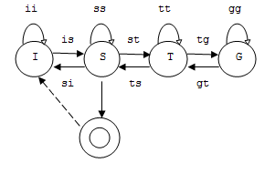

Initially, all leg states are presumed to be Support, and decoded as neutral position. In software, this is represented by an enumerated type, legRole:
enum legRole { Support, Transition, Gesture, Unknown };
(Logic for the leg grammar transitions is described later, and relies on the factors discussed next.)
Since we supposed a purely random dancing robot has a fair chance of damaging its servos eventually, we have to select some reasonable constraints under which dancing will occur. Initially, a notion of platform stability was proposed, which led to the following leg-logic derivation:
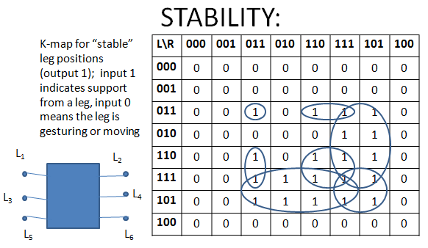

Stable = (L₁L₅L₄)+(L₃L₂L₆)+(L₁L₃L₂L₄)+(L₁L₅L₂L₆)+(L₃L₅L₄L₆)+(L₁L₃L₄L₆)+(L₃L₅L₂L₄)

Essentially, each stance satisfying a min-term of the equation can be viewed as a combination that keeps the body steady: all legs supporting, five legs supporting, four legs supporting, or tripod support. This constraint is expressed by the Boolean function nextCanLift().
During improvisation, at each step, each leg is evaluated in a random order according to the grammar and the stability constraints. There are probabilities associated with each possible transition, plus some demands of the stability constraint and whether the dance is continuing.
At each beat, R is a fresh random number between 0 and 99, #S is taken to be the number of legs already evaluated to be in the Support role for the next position, and #G is the number evaluated in the Gesture role.

Initial –
is := Dancing
ss := !Dancing

Support -
st := (R < Pst) && (#S > 2) && (nextCanLift())
ss := !st && Dancing
si := !Dancing
P_{ss} = 40
P_{st} = 60

Transition -
ts := !Dancing || (#S < 3) || (R < Pts)
tg := !ts && ((R < Pts + Ptg) && (#G < 3))
tt := !ts && !tg
P_{tt} = 20
P_{ts} = 40
P_{tg} = 40

Gesture -
gt := (R < Pgt) || !Dancing
gg := !gt
P_{gg} = 50
P_{gt} = 50

Once the next leg state combination is determined, the leg state values are encoded into a single variable which is used by the decoder to identify the appropriate MoveSet from which to select, at random, a matching group of servo positions for the leg state combination. The levels of indirection were resolved through a simple binary encoding of the “leg word” which then mapped to a MoveSet structure.
Conceptual flow of the improvisational dance machine
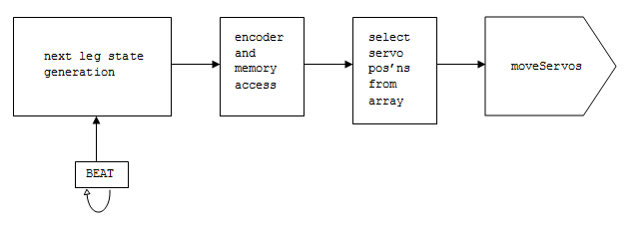

Example of a valid sequence of leg movement “words”
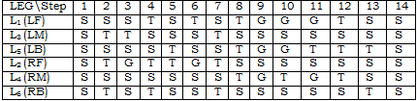

Definitions of the various MoveSet structures are in file dancePositions.h.
There are 769 total possible leg grammar states, but less than 10% meet the balance constraints, leading to 73 total improvisational MoveSets. However, each of these has an array containing a number of possibilities, from which the machine selects at random. Furthermore, many of the servo positions themselves are tagged as RANDM, and result in bounded random servo positions when interpreted by the moveServos layer. This constrained random behavior gives the robot a constrained and coherent, yet unpredictable, dance during which the robot moves to the beat, but maintains a degree of stability and doesn’t actually move around much.
The head servos also have entries in the MoveSet arrays, and while they play an important aesthetic role in the dance, they aren’t considered part of the leg grammar. Generally, if a leg is gesturing, the head servos are positioned randomly. Otherwise, each head servo has an equal chance of being neutrally or randomly positioned.

Inverting our Assumptions
At some point, we accidentally reversed the polarity of our signed integer offset for raising a leg, causing the robot to *lower* its legs for transitions instead of raising them. This resulted in a crazy bucking dance where the gesturing happens on legs lower than those nominally doing the supporting. This dance is somewhat more entertaining to watch, albeit probably a bit harder on the legs and servos. The constraints still apply, in reverse, so no more than 3 legs are pivoting at a time, and the non-gesturing legs tend to stay still and out of the way.

Rocky Chase

Future improvements

Beat Detection
The beat detection currently does not work well with music that has a bass line that uses a square wave. This is because there is no anti-aliasing filter between the microphone and the inputs of the ACD on the Arduino board. The higher frequency components of the square wave sum up and end up producing a higher peak than the kick drum. There are several possible solutions to this problem.
A dedicated analog beat detection circuit could be used to supply the Arduino with a movement trigger. These beat detection circuits require only a few components and the designs for these are available on the internet.
The other obvious solution is to add an anti–aliasing filter between the microphone and the input of the ADC on the Arduino. This filter would not need to have tight specifications since we only need to slightly reduce the amplitude of the high frequency components. A simple RC filter might be sufficient.

MIDI Control
MIDI input would be another option for beat detection and motion control. MIDI is an interface for electronic music instruments that produces note and timing information. There are many standalone boxes that play music and have a midi out to control other instruments. The dancing hexapod could be controlled as if it is an instrument in the MIDI chain. The robot could either trigger its movements to the beat provided by the MIDI signal or custom movement commands could be sent. This provides a way to choreograph custom movements with custom music.

Grammar Decoding Enhancement
Currently our improve routine in the normal mode only rotates the shoulders on legs that are not touching the ground. The improv routine could be modified to allow legs touching the ground to move, as long as all of the legs on that side of the robot move in the same direction. That way the robot can move a step forward, a step back, rotate left, rotate right as part of its improv routine. During one of these movements, the retracted legs could still rotate freely.

Integration of Scripted Move Sets
Scripted move sets were originally used by our group before the improv routine was created. The overall improv routine could change to allow scripted routines to execute at random in between the pure improv movements.

Appearance
The robot could be dressed up a bit, perhaps some special baggie pants could cover the legs and the wiring. Also the head of the robot could be decorated.

Movement Interpolation and Transforms
Currently when we move a servo we simply give a destination position for the servo. We could however interpolate N positions between the servos last know position and its destination position. Once this list of points is obtained transforms can be performed. For instance a low pass filter could be applied to the movement or shaping of the movement could make the movement look like a curve rather than a line.

Appendix

Josh Gerwin

SOFTWARE SYMBOLS BY FILE (some of them, anyway)
improv_machine.pde (top-level Arduino project file)
NAME | TYPE | DESCRIPTION
MicPin | const int, hw input | microphone connection to analog pin
BeatLED | const int, hw output | LED that blinks briefly on a peak
rxPinRight | const int, hw input | serial input to right SSC
txPinRight | const int, hw output | serial output to right SSC
rxPinLeft | const int, hw input | serial input to left SSC
txPinLeft | const int, hw output | serial output to left SSC
Dancing | boolean | whether the robot is dancing
DanceLED | const int, hw output | LED indicator for Dancing
LoopDelay | const int | how long to wait before restarting loop()
DanceListSize | int | deprecated, length of a scripted move set
iPower | inline int(int, int) | lightweight arithmetic function used to invert head motions during setBeatsPerMin()
setup | void(), Arduino API | initialize the program, do things that only get done once and/or have to be resolved at the beginning
loop | void(), Arduino API | main function, this will repeat itself automatically as long as the Arduino runs

roboDance.h (included from improv_machine.pde, precompiler definitions)
moveFuncs.h (included from improv_machine.pde, servo motion layer)
NAME | TYPE | DESCRIPTION
SoftSerialLeft | SoftwareSerial | serial I/O object for the left SSC
SoftSerialRight | SoftwareSerial | serial I/O object for the right SSC
SoftSerial | SoftwareSerial[] | deprecated, serial I/O array
ShoulderSpeed | int | speed for shoulder servos
LegSpeed | int | speed for leg servos
HeadSpeed | int | speed for head servos
Range | int | mask for motion bits (Pololu SSC protocol)
Neutral | int[] | nominal neutral servo position array
CurrentPosition | int[] | current servo positions
ListElement | int | array index for doMoveSet function
setServoPosition | void(byte, int) | servo pos’n control for Pololu SSC, mode 4
setServoSpeed | void(byte, byte) | servo speed control for Pololu SSC, mode 1
moveServos | void(int[]) | super cool servo group move function
doMoveSet | void(int[][],int) | used for scripted move sets

dancePositions.h (included from improv_machine.pde, mostly servo position arrays, omitting and/or abbreviating most of them here)
NAME | TYPE | DESCRIPTION
MoveSet | struct {int *, int} | container structure for arrays of servo position vectors and length of those arrays
posNeutralAll | void() | returns servos to their neutral positions
NeutralAll | PROGMEM prog_int16_t[] | servo vector for neutral positon
Tripod_StepForward | PROGMEM prog_int16_t[][] | simple tripod movement sequence
Tripod_StepBackward | PROGMEM prog_int16_t[][] | simple tripod movement sequence
NAME | TYPE | DESCRIPTION
Tripod_TurnLeft | PROGMEM prog_int16_t[][] | simple tripod movement sequence
Tripod_TurnRight | PROGMEM prog_int16_t[][] | simple tripod movement sequence
mTripod_StepForward | MoveSet | contains Tripod_StepForward
mTripod_StepBackward | MoveSet | contains Tripod_StepBackward
mTripod_TurnLeft | MoveSet | contains Tripod_TurnLeft
mTripod_TurnRight | MoveSet | contains Tripod_TurnRight
SSSSSS | PROGMEM prog_int16_t[][] | leg role-based viable position array
... | ... | ... (omitting 71 similar arrays)
GSGSGS | PROGMEM prog_int16_t[][] | leg role-based viable position array
mSSSSSS | MoveSet | contains SSSSSS
... | ... | ... (omitting 71 similar structs)
mGSGSGS | MoveSet | contains GSGSGS
allMoveSets | MoveSet*[] | array of the addresses of 73 MoveSets containing the viable servo positions for improvisation
Important! Note use of PROGMEM for position arrays in dancePositions.h to use the Arduino board's flash memory, so servo positions must be explicitly retrieved from flash storage before they're passed to the servo movement layer. This is platform specific, due primarily to the fact that the Arduino's Atmega microcontroller has only 2k of SRAM memory which the compiler likes to allocate to string and integer literals as well as space for modifiable variables of all kinds (serial communication queues, e.g.). For more details on Arduino memory organization, refer to:
http://www.arduino.cc/playground/Learning/Memory
http://www.arduino.cc/en/Reference/PROGMEM
improvStateMachine.h (included from improve_machine.pde, improvisation application)
NAME | TYPE | DESCRIPTION
legRole | enum { Support, Transition, Gesture, Unknown } | provides legibility for the leg grammar operations
InitialLegState | legRole[6] | Support x 6
CurrentLegState | legRole[6] | holds the current leg roles
NextLegState | legRole[6] | next beat leg roles
EvaluationOrder | int[6] | enables random evaluation order
RandomValues | int[6] | assists EvaluationOrder
ServoPositionList | int[14] | vector sent to moveServos on every beat of improvisation
printIntVec | void(int[], int) | prints an integer vector
P_ST | int | chance in 100 of change from Support role to Transition role
... | ... | ... (omitting 5 similar ints)
P_GG | int | chance in 100 of leg remaining in Gesture role
setRandomValues | void() | put 6 random values in RandomValues
setEvaluationOrder | void() | put ints from 1 to 6 in EvaluationOrder based on RandomValues
genLegBits | int | concat 6 legRoles to a single int
clearNextState | void() | sets NextLegState to Unknown x 6
NAME | TYPE | DESCRIPTION
loadServoPositionFromFlash | void() | takes a servo vector from Flash to ServoPositionList
nextCanLift | bool(int) | evaluates whether a leg can leave its support role in the next beat
evaulateNextState | void() | assigns each leg to its next role based on improvisation rules
selectRandomServoPositions | int *(MoveSet *) | selects a random servo position vector from an array in a MoveSet
decodeLegState | void(int) | maps leg bits to MoveSets and selects a servo vector to execute from the set at random
doImprovStateMachine | void() | call evaluateNextState, decodeLegState, and copy NextLegState to CurrentLegState

Resources by Topic

- Arduino Duemilanove
- Description: http://arduino.cc/en/Main/ArduinoBoardDuemilanove
- Schematic: http://arduino.cc/en/uploads/Main/arduino-duemilanove-schematic.pdf
- Arduino IDE
- Download: http://arduino.cc/en/Main/Software
- Language reference: http://arduino.cc/en/Reference/HomePage
- Pololu SSC
- Datasheet: http://www.sparkfun.com/datasheets/Robotics/ssc03a_guide.pdf
- ADMP401 Microphone
- Datasheet: http://www.analog.com/static/imported-files/data_sheets/ADMP401.pdf
- Breakout board schematic: http://www.sparkfun.com/datasheets/BreakoutBoards/ADMP401-Breakout-v13.pdf
- Beat Detection
- Adam Greig’s audio peak detector: https://randomskk.net/projects/lightstrip/code.html
- Servos
- Hitec HS-300: http://www.servodatabase.com/servo/hitec/hs-300
VII. Frame
- Outdated Lynxmotion frame similar to what we started with: http://www.lynxmotion.com/images/html/build032.htm

